Project Ideas:

* **Main Page**:

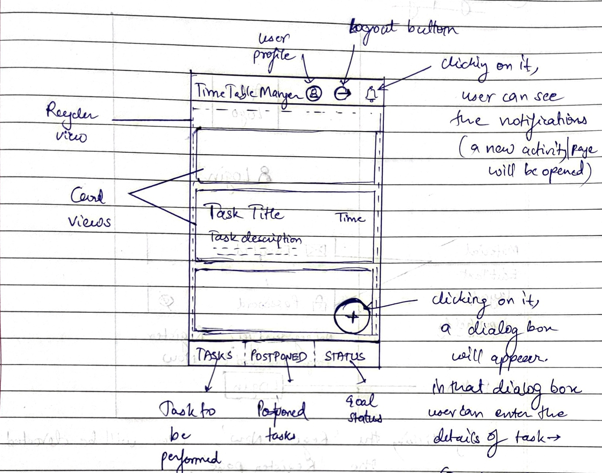



* This page will open when user presses the LOGIN button in the login page, or if the user is already logged in.
* Each Fragment will have a recycler view
* Each recycler view will have several card views, depending on the number of tasks user has added.
* Each card view layout will be same (only dataset will be changed)
* Card view layout:

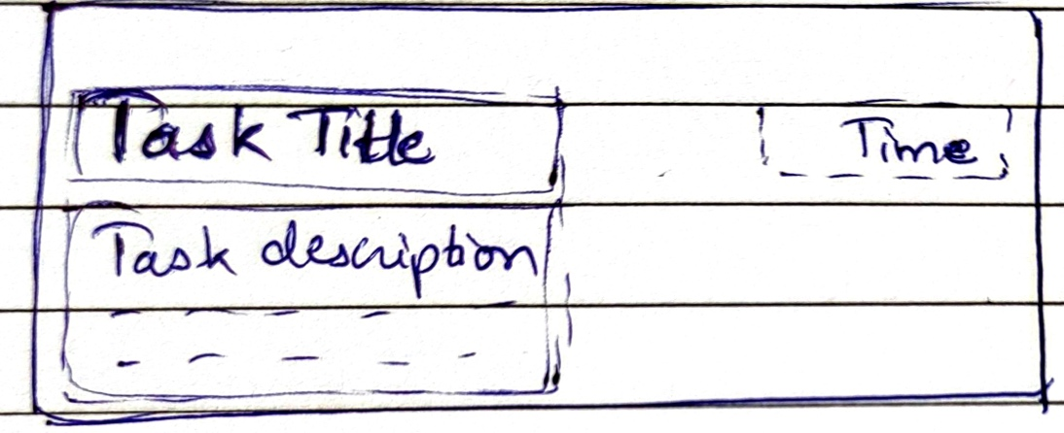



* Can also add the option of deleting and editing a task by swiping left/right feature.
* On clicking the floating action button, this dialog box will appear:

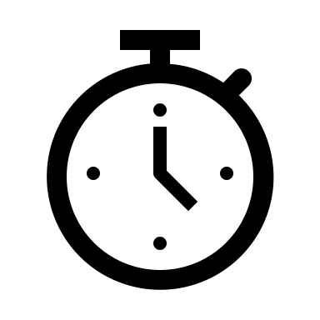

11:29 AM

Date

Repeat

CANCEL

ADD

Short Description….

Title of Task

**ADD NEW TASK**